**PROGRAMMING TECHNIQUE I SECJ1013-01**

**ASSIGNMENT 1**

**2022/2023**

**TITLE: PROGRAMMING PROBLEM-SOLVING**

NAME / MATRICS NUMBER: JANE NG JING YING / A22EC0170

SIOW XIN YA / A22EC0269

DATE: 06/11/2022

**QUESTION 1 [5 MARKS]**

Determine the output for each run of the pseudo code in **Figure 1** for the given inputs in **Table 1**. Write your answers in **Table 1**.

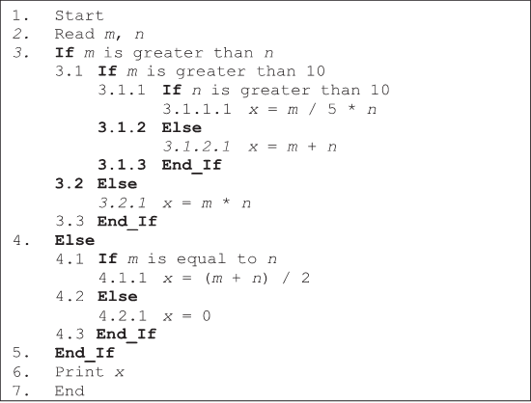

**Figure 1:** Pseudo code

**Table 1:** Tracing table

|  |  |  |
| --- | --- | --- |
| ***m*** | ***n*** | **Output** |
| 12 | 5 | 17 |
| 15 | 10 | 25 |
| 5 | 17 | 0 |
| 8 | 8 | 8 |
| 20 | 15 | 60 |

**QUESTION 2 [11 MARKS]**

The flowchart in **Figure 2** represents a nested loop to collect data and calculate the average rainfall over a period of years. First, the program should ask for the number of years. The outer loop will iterate once for each year. The inner loop will iterate 12 times for each year. Each iteration of the inner loop will ask the user for the inches of rainfall for that month. After all iterations, the program should display the number of months, the total inches of rainfall, and the average rainfall per month for the entire period.

**Input Validation:** Do not accept a number less than 1 for the number of years. Do not accept negative numbers for the monthly rainfall.

Fill in the blank graphical symbols with question mark (?) and roman numbers in **Figure 2**

with appropriate instructions. Write your answers in **Table 2**.

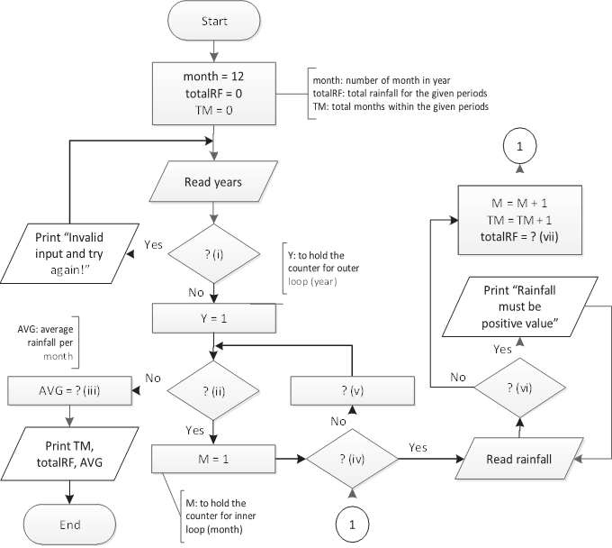

**Figure 2:** Flowchart

**Table 2**

|  |  |
| --- | --- |
| **Question** | **Instruction** |
| (i) | Y<1 |
| (ii) | TM=0 |
| (iii) | AVG = totalRF/month |
| (iv) | TM<12 |
| (v) | Y=Y+1 |
| (vi) | rainfall<0 |
| (vii) | totalRF = totalRF + rainfall |

**QUESTION 3 [14 MARKS]**

Trace the execution of the flowchart in **Figure 3** and **Figure 4** by filling in the tracing tables in

**Table 3** and **Table 4** accordingly.



**Figure 3:** Flowchart 1 **Figure 4:** Flowchart 2

**Table 3:** Tracing table 1 **Table 4:** Tracing table 2

|  |  |  |  |  |
| --- | --- | --- | --- | --- |
| **P** | **Q** | **R** | **(P % 2 = 0) &&**  **(Q % 2 = 0)** | **P<Q** |
| 3 | 5 | 8 | No | Yes |
| 4 | 4 | 3 | Yes | No |
| 5 | 3 | 2 | No | No |
| 6 | 2 | 3 | Yes | No |
| 7 | 1 | 6 | No | No |
|  |  |  |  |  |
|  |  |  |  |  |
|  |  |  |  |  |

|  |  |  |  |  |
| --- | --- | --- | --- | --- |
| **A** | **B** | **X** | **X<5** | **Z** |
| 3 | 5 | 0 | Yes | (3, 5) |
| 4 | 4 | 1 | Yes | (4, 4) |
| 5 | 3 | 2 | Yes | (5, 3) |
| 6 | 2 | 3 | Yes | (6, 2) |
| 7 | 1 | 4 | Yes | (7, 1) |
| 8 | 0 | 5 | No | (8, 0) |
|  |  |  |  |  |
|  |  |  |  |  |

**QUESTION 4 [15 MARKS]**

Draw a flowchart which reads in two integer values. Then, display all the numbers that is located between the two numbers. Please consider the following conditions:

1. If the first number entered is smaller than the second number entered, print all numbers in ascending order by using a **pre-test** loop.
2. If the first number entered is greater than the second number entered, print all numbers in descending order by using a **post-test** loop.

**Table 5** shows an examples of input and output. The user’s input is shown in **bold**.

**Table 5:** Examples of input and output

|  |  |  |
| --- | --- | --- |
| **Example** | **Input** | **Output** |
| 1 | **3 8** | 3 4 5 6 7 8 |
| 2 | **15 12** | 15 14 13 12 |
| 3 | **4 4** | *No output will be displayed* |
| 4 | **19 23** | 19 20 21 22 23 |

***(Space for Answer of Part A: Question 4)***

**PART B: PROBLEM SOLVING**

**QUESTION [34 MARKS]**

Using flowcharts, design the algorithm for a program based on the problem given. Develop a program that asks the user to enter a distance in meters. The program will then present the following menu of selection:

* 1. Convert to kilometres
  2. Convert to inches
  3. Convert to feet
  4. Quit the program.

The program will convert the distance to kilometres, inches, or feet, depending on the user’s selection.

Here are the specific requirements:

1. Draw the flowchart for a function named *showKilometers*, which accepts the number of meters as an argument. The function should display the argument converted to kilometres. Convert the meter to kilometres using the following formula :

kilometres = meters  0.001

1. Draw the flowchart for a function named *showInches*, which accepts the number of meters as an argument. The function should display the argument converted to inches. Convert the meter to inches using the following formula :

inches = meters  39.37

1. Draw the flowchart for a function named *showFeet*, which accepts the number of meters as an argument. The function should display the argument converted to feet. Convert the meter to feet using the following formula :

feet = meters  3.281

1. Draw the flowchart for a function named *displayMenu* that displays the menu of selection. This function should not accept any arguments.
2. The program should continue to display the menu until the user enters **4** to quit the program.
3. The program should not accept negative numbers for the distance in meters.
4. If the user selects an invalid choice from the menu, the program should display an error message.

Figure 5 is an example session with the program, using console input. The user’s input is shown

in **bold**.

Enter a distance in meters: **500 [Enter]**

1. Convert to kilometres
2. Convert to inches
3. Convert to feet
4. Quit the program.

Enter your choice : **1 [Enter]**

500 meters is 0.5 kilometers.

1. Convert to kilometres
2. Convert to inches
3. Convert to feet
4. Quit the program.

Enter your choice : **3 [Enter]**

500 meters is 1640.5 feet

1. Convert to kilometres
2. Convert to inches
3. Convert to feet
4. Quit the program.

Enter your choice : **10 [Enter]**

ERROR! Invalid Input.

1. Convert to kilometres
2. Convert to inches
3. Convert to feet
4. Quit the program.

Enter your choice : **4 [Enter]**

BYE!

**Figure 5:** Example of inputs and outputs

This program asks the user to enter the distance in meters. It converts the distance in meters based on user’s choices and displays the value on the screen.

Start

Set counter = 1

False

False

True

True

True

False

feet

inches

kilometres

Read choice

Display “Enter your choice”

Display the menu of selection

“1. Convert to kilometres

2. Convert to inches

3. Convert to feet

4. Quit the program.”

Read meters

Display “Enter a distance in meters”

1

Choice == 3

Choice == 2

Choice == 1

False

True

inches

Read meters

inches = meters * 39.37

Print inches

Return

feet

Read meters

feet = meters * 3.281

Print feet

Return

Return

Print kilometres

kilometres = meters * 0.001

Read meters

kilometres

Display “ERROR! Invalid Input.”

End

Set counter = 0

Display “BYE!”

Choice == 4

1